**Text User Interface**

Intro/Outro

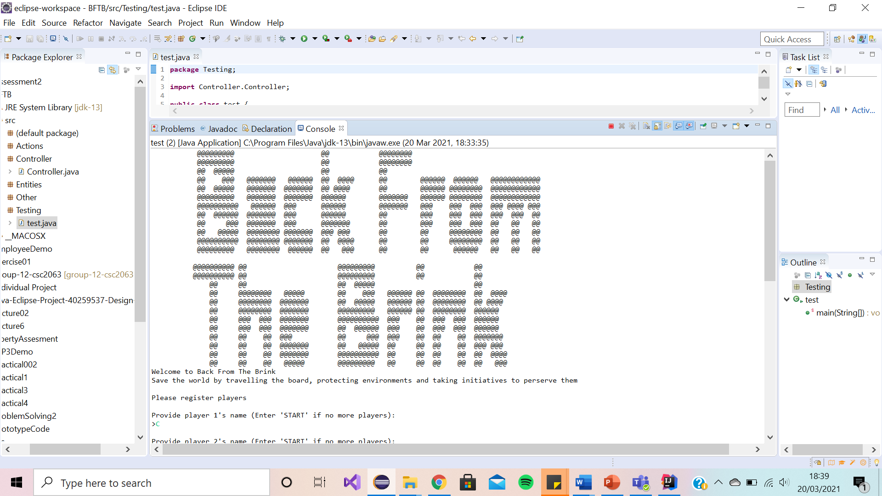

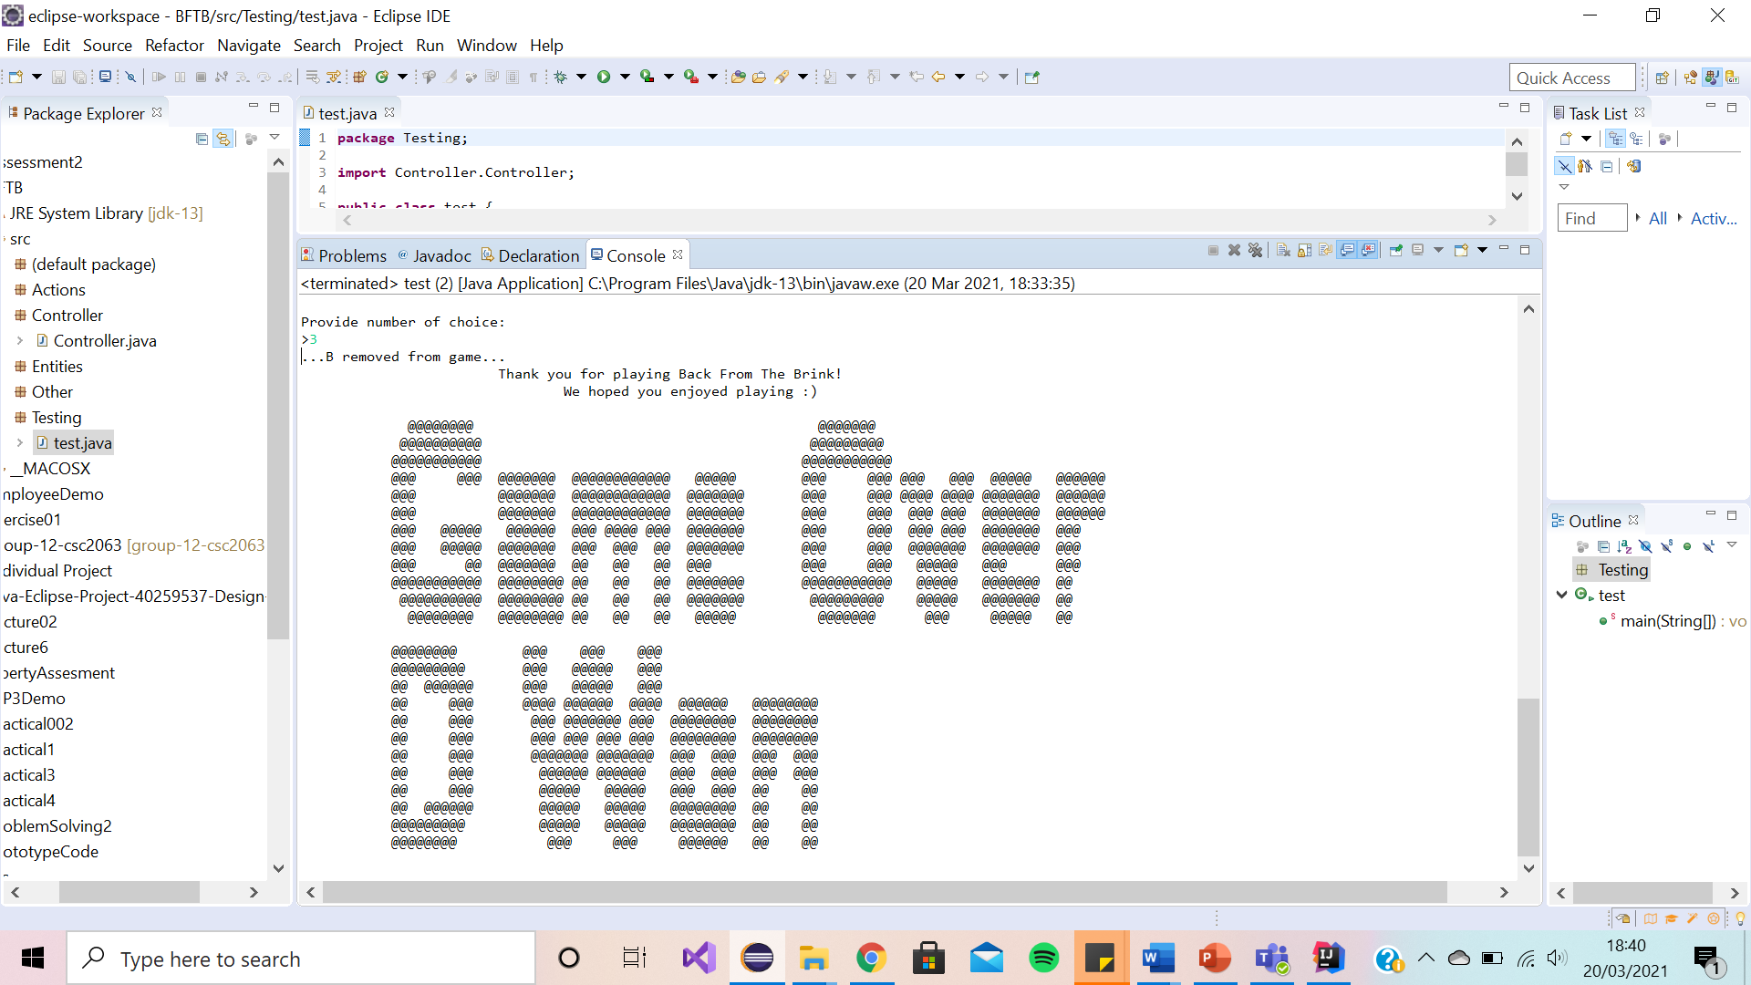

We have decided to use ASCII Art for the ‘Back from the Brink’ intro and outro to make the game more eye catching to the players. This will therefore draw in their interest.

Game Scenario Message

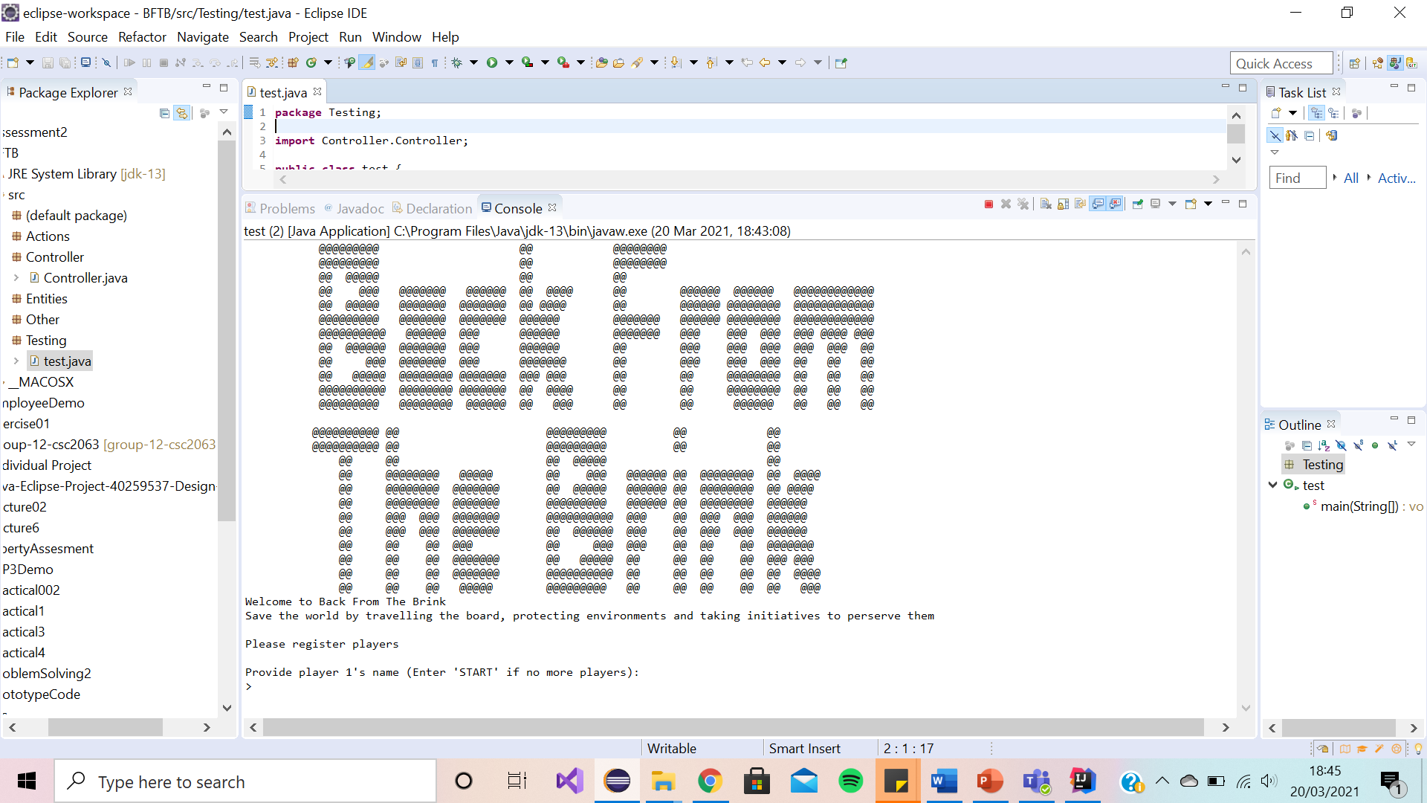

We have decided to lay the game scenario message (as shown above) as a print statement as it sets the scene for the players, attracting their interest from the start. We have kept it short to keep reading minimal therefore allowing the players to start the game quickly.

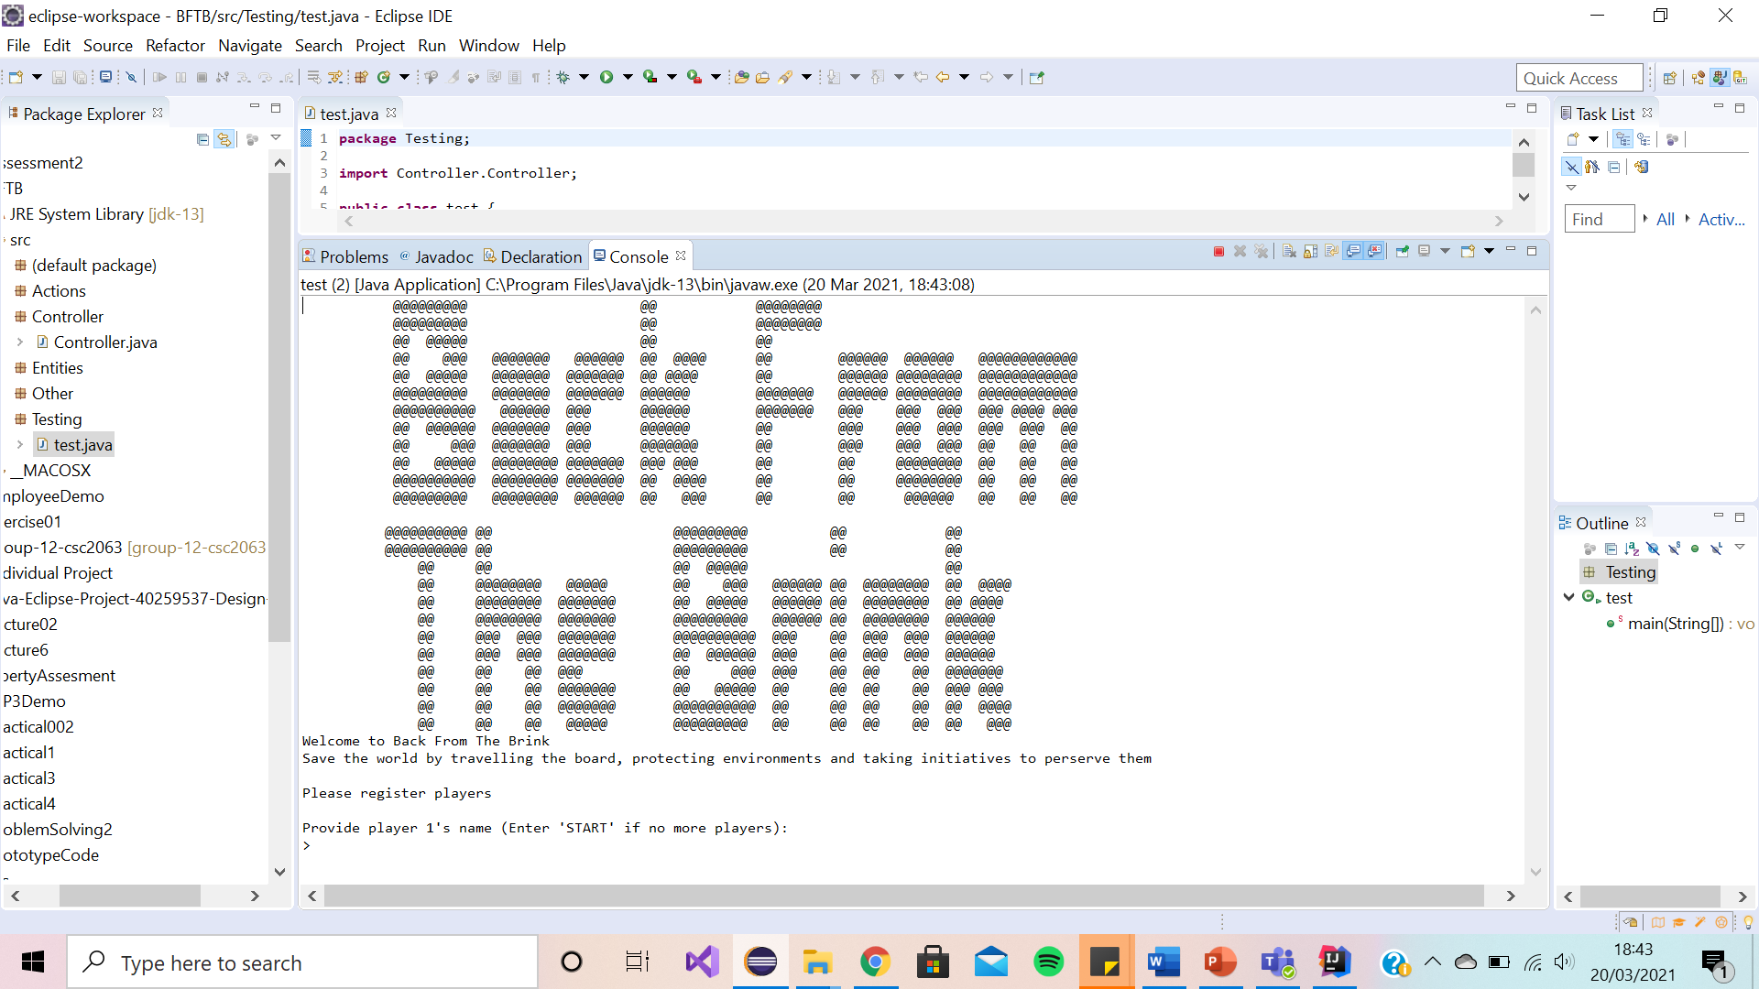Registering Players Prompt

We have decided to lay the registering players prompt (as shown above) as a simple enter your player’s name in the text box as it is brief and exactly tells the player what they must do to register themselves as a player to start the game.

Enter Choice Prompt

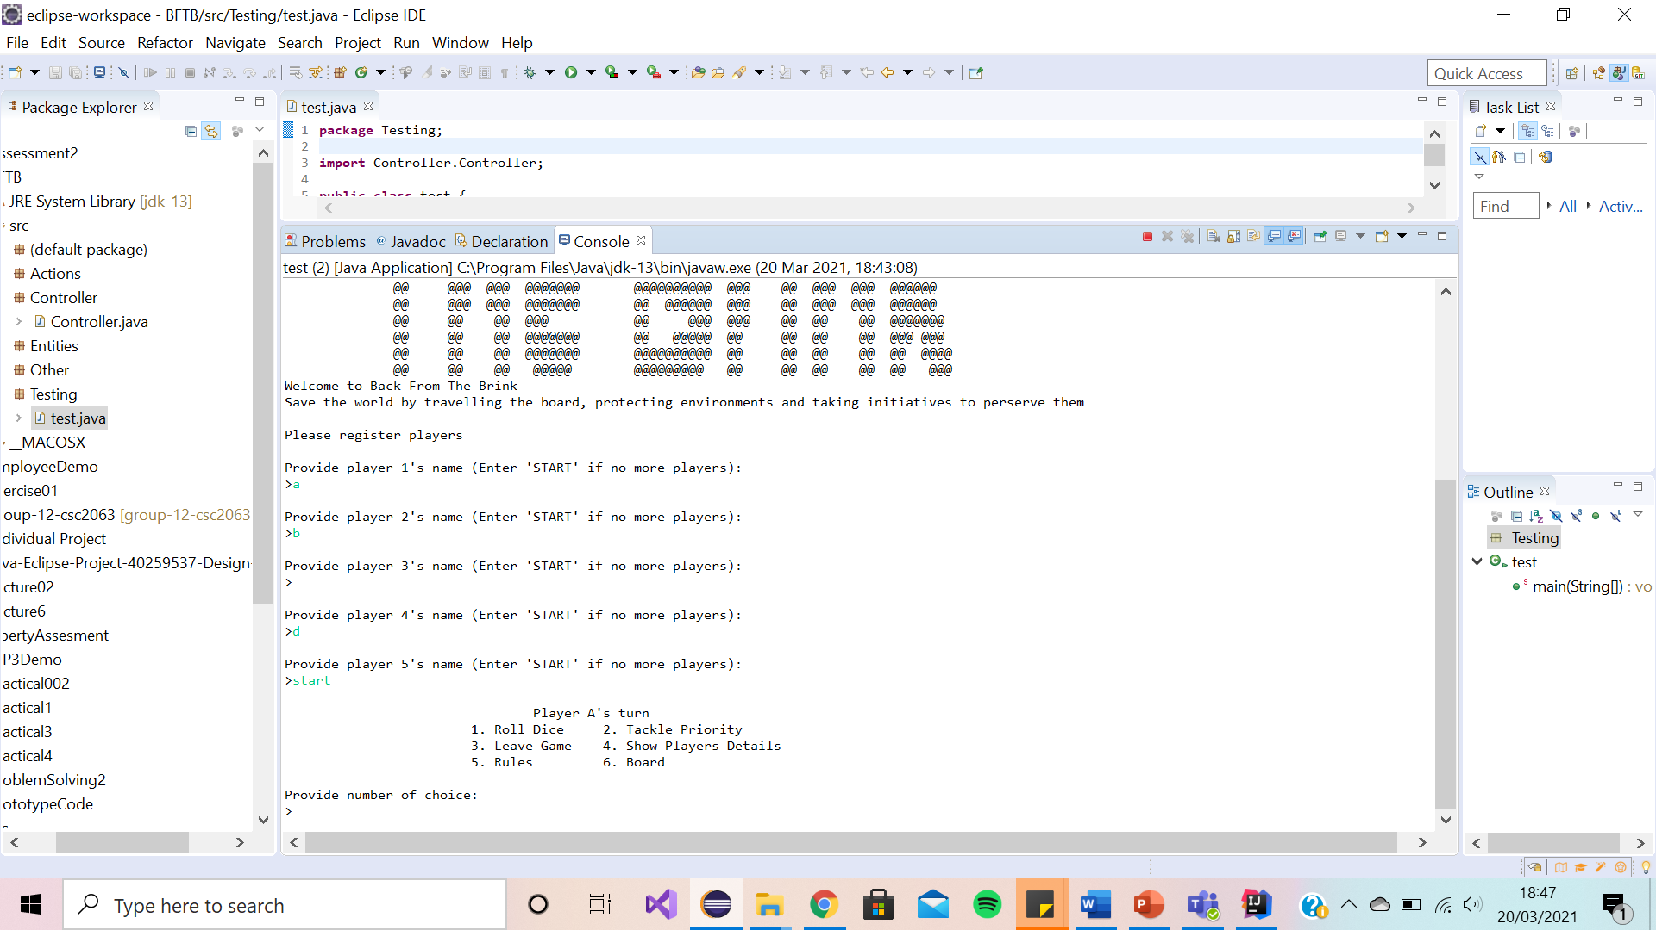

We have decided to lay the enter choice prompt (as shown above) as a switch statement as it clearly lays out the list of options the player to choose from. This avoids any human errors, and it reduces the amount of typing the user has. We have minimised the number of choices the player can chose from as having too many choices may over complicate the game for the player

Invalid Option Message

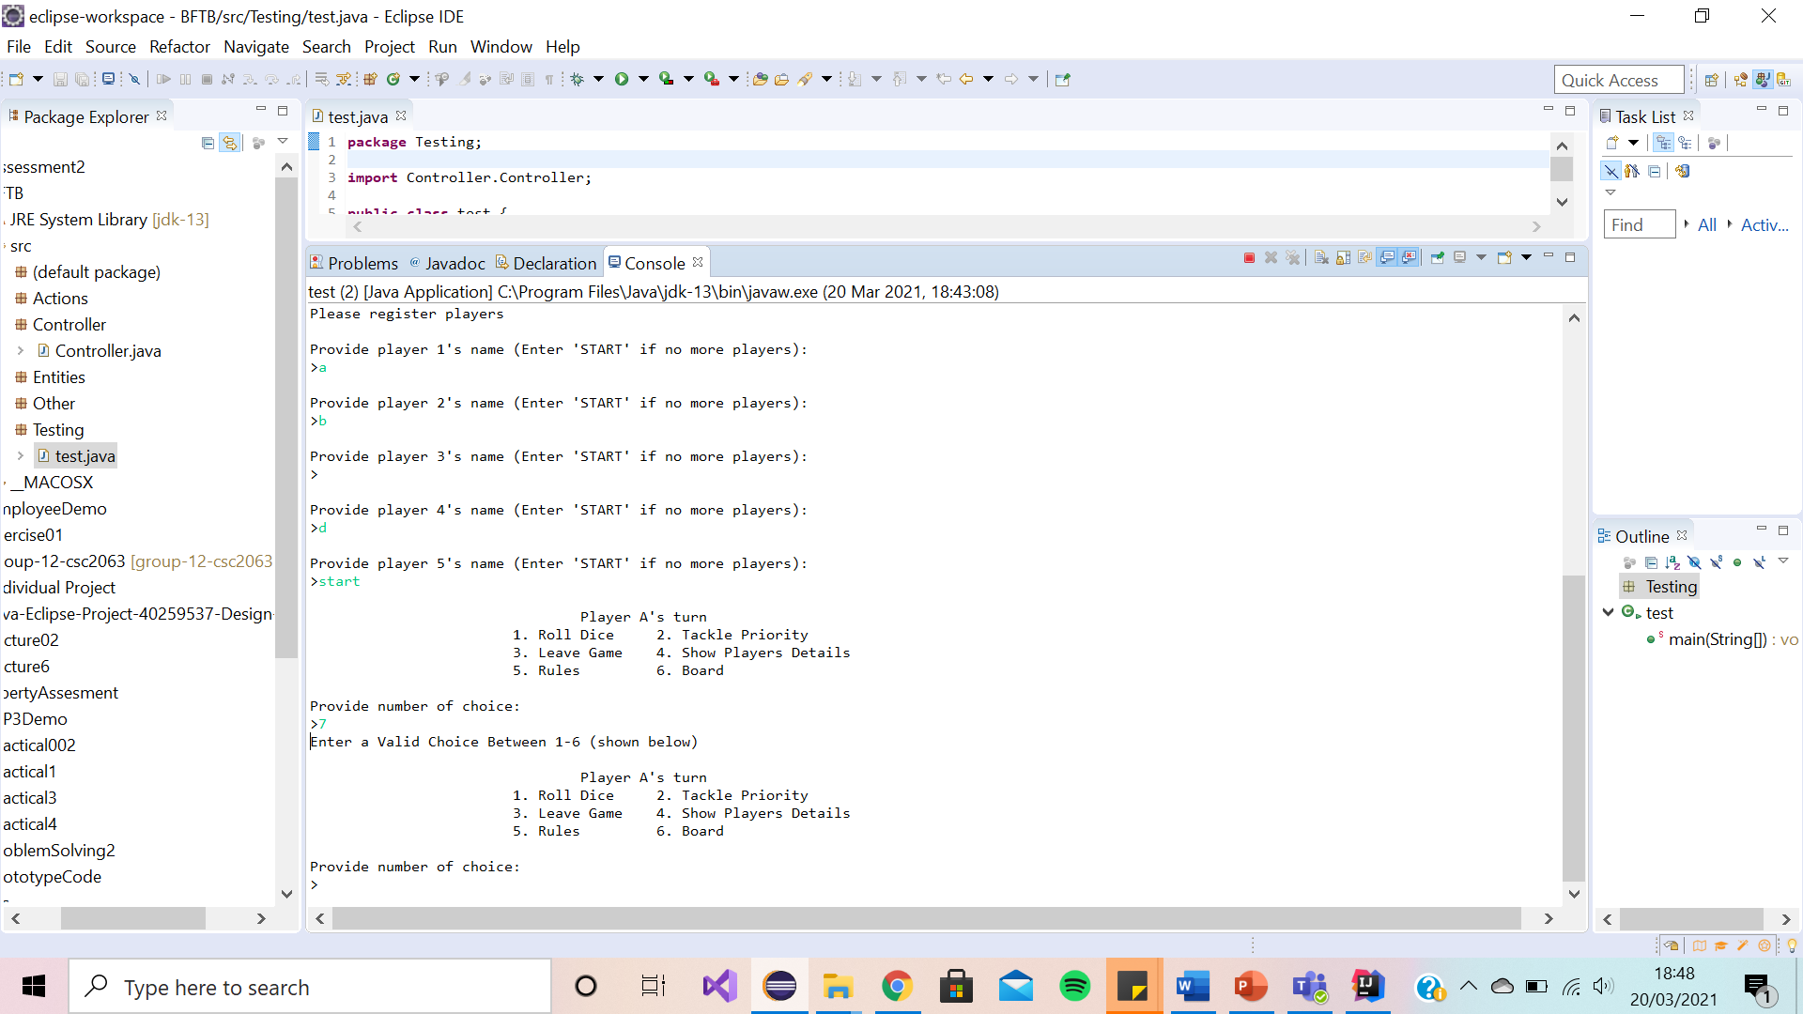

We have decided to lay the invalid choice prompt (as shown above) as a switch statement as it is concise, and it politely tells the user this is an invalid option. It suggests to them how they can resolve this error. This therefore helps the user to continue playing with the game.

Player Details (Summary)

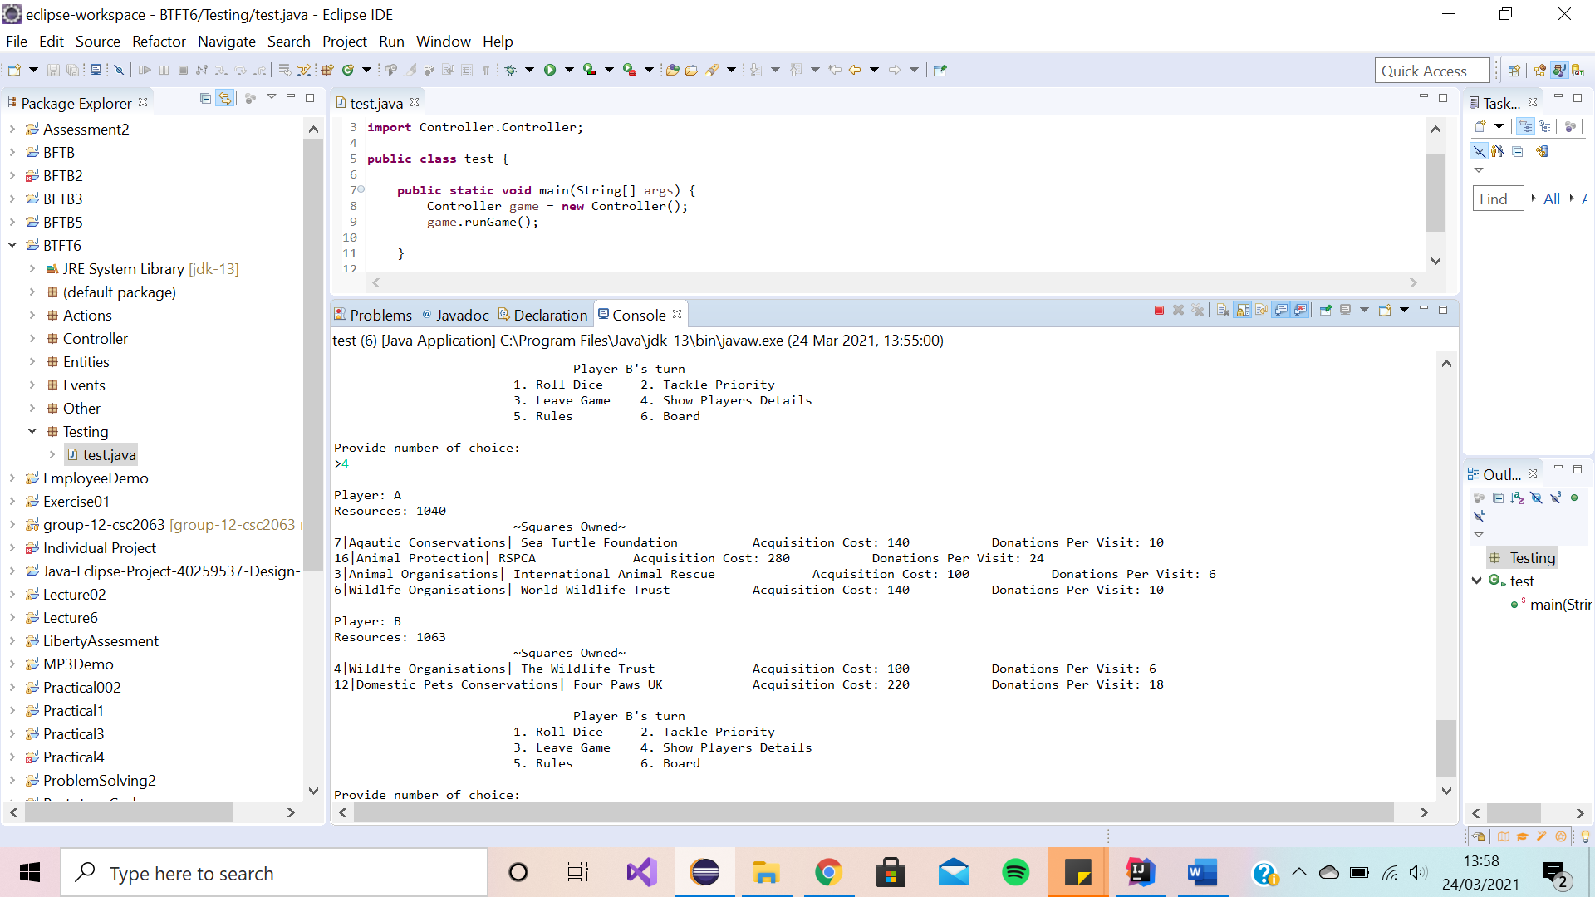

We have decided to lay the player details summary (as shown above) as a simple print statement. This provides the players with all the relevant details such as player names, player balance and their owned priorities (with their associated costs). We have chosen to show these details as we believe they are the most important and appropriate to the players.

Rules Message

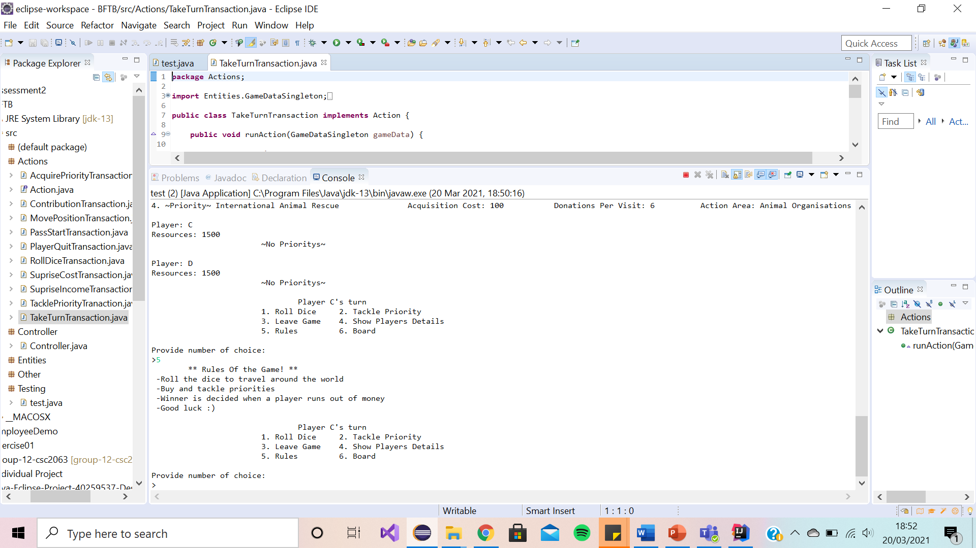

We have decided to lay the rules message (as shown above) as a simple print statement as players would not want a long paragraph of rules to try read and understand. It simply and clearly lays out the rules of the game.

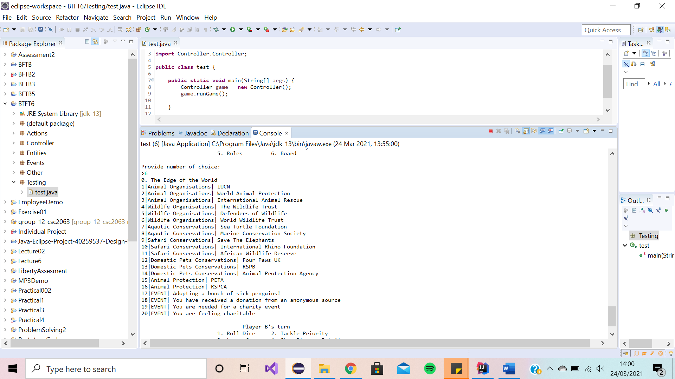Board Summary

We have decided to include a board summary (as shown above) as a print statement to visualise for the player the board. We have included a list of all the priorities names on the board as well as surprise events.

Ending Message

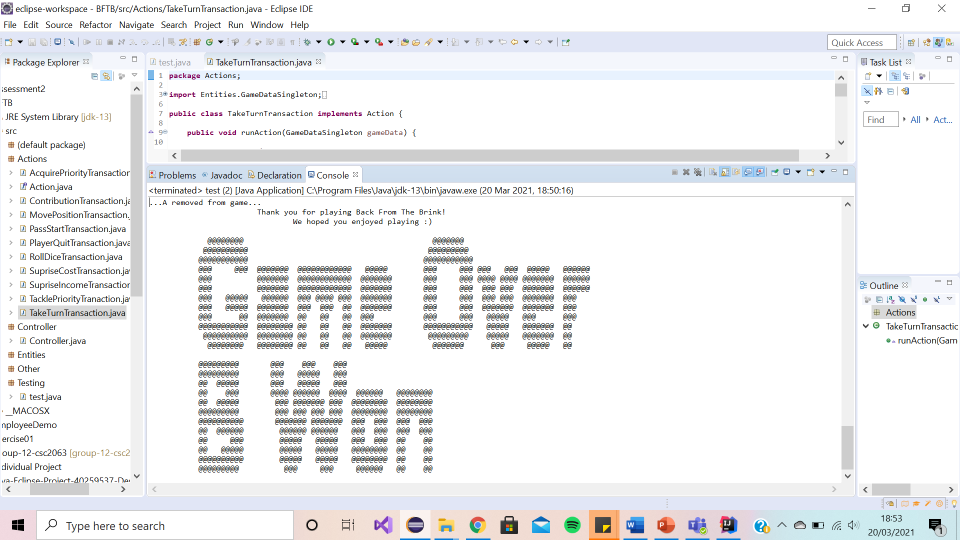

We have decided to lay the ending message (as shown above) as a print statement as it shows appreciation to the player for playing the game encouraging the player to want to play again.